**COMP-CO710 Midterm Practice Test - Weather**

**Aids:**

You may use the following web sites as resources:

w3schools.com

HTML and CSS validators from w3.org

**Requirements:**

You will create the weather.html and weather.css files. Screen captures of the weather.html page rendered in the browser are shown below. Marks indicated include both content and CSS where appropriate.

**General**

* Create the HTML and CSS code required to display the weather.html page in the browser as shown in the images on the pages below.
* HTML and CSS must be valid code. Use the w3c.org validators to troubleshoot and ensure all code is conforms to current standards.
* Code must use proper indentation.
* Include a comment in each file indicating your name and student number.
* Images are provided. Preserve the folder structure, but you may change the names of the images if you wish.

### HTML and CSS

* The title on the weather.html file must be **Weather**
* Text for paragraphs can be found in the weather.txt file.
* Colors used in this site:
  + fdb924, 808080, 494e6c, black, white
* The font should be Arial, Helvetica, Verdana, sans-serif
* Layout
  + Make use of grid and flexbox to position elements where appropriate. Float should be used only when text wrapping is required around an element.
  + Make use of grid-gap, padding and margins to add whitespace where needed.
* Nav
  + Use an unordered list for nav items and style as shown in the image.
  + Nav items are links that all point to #.
  + Nav items have a hover effect shown below.



* + The nav should stay at the top of the screen when the user scrolls to the bottom of the page.
* Header
  + Social media icons should be links that point to facebook.com, twitter.com, Instagram.com and email to [weather@example.com](mailto:weather@example.com)
* Main
  + The Clouds column should be a fixed width, the same as the clouds image.
* Footer
  + Social media icons and their links are the same as in the Header element.

### External and Embedded CSS

* Place the CSS for the header, nav and footer in an external CSS file called weather.css and link to this file in the HTML file.
* All other CSS should be embedded in the weather.html file.

Dotted line shows the edge of the page. Do not include a dotted line border.

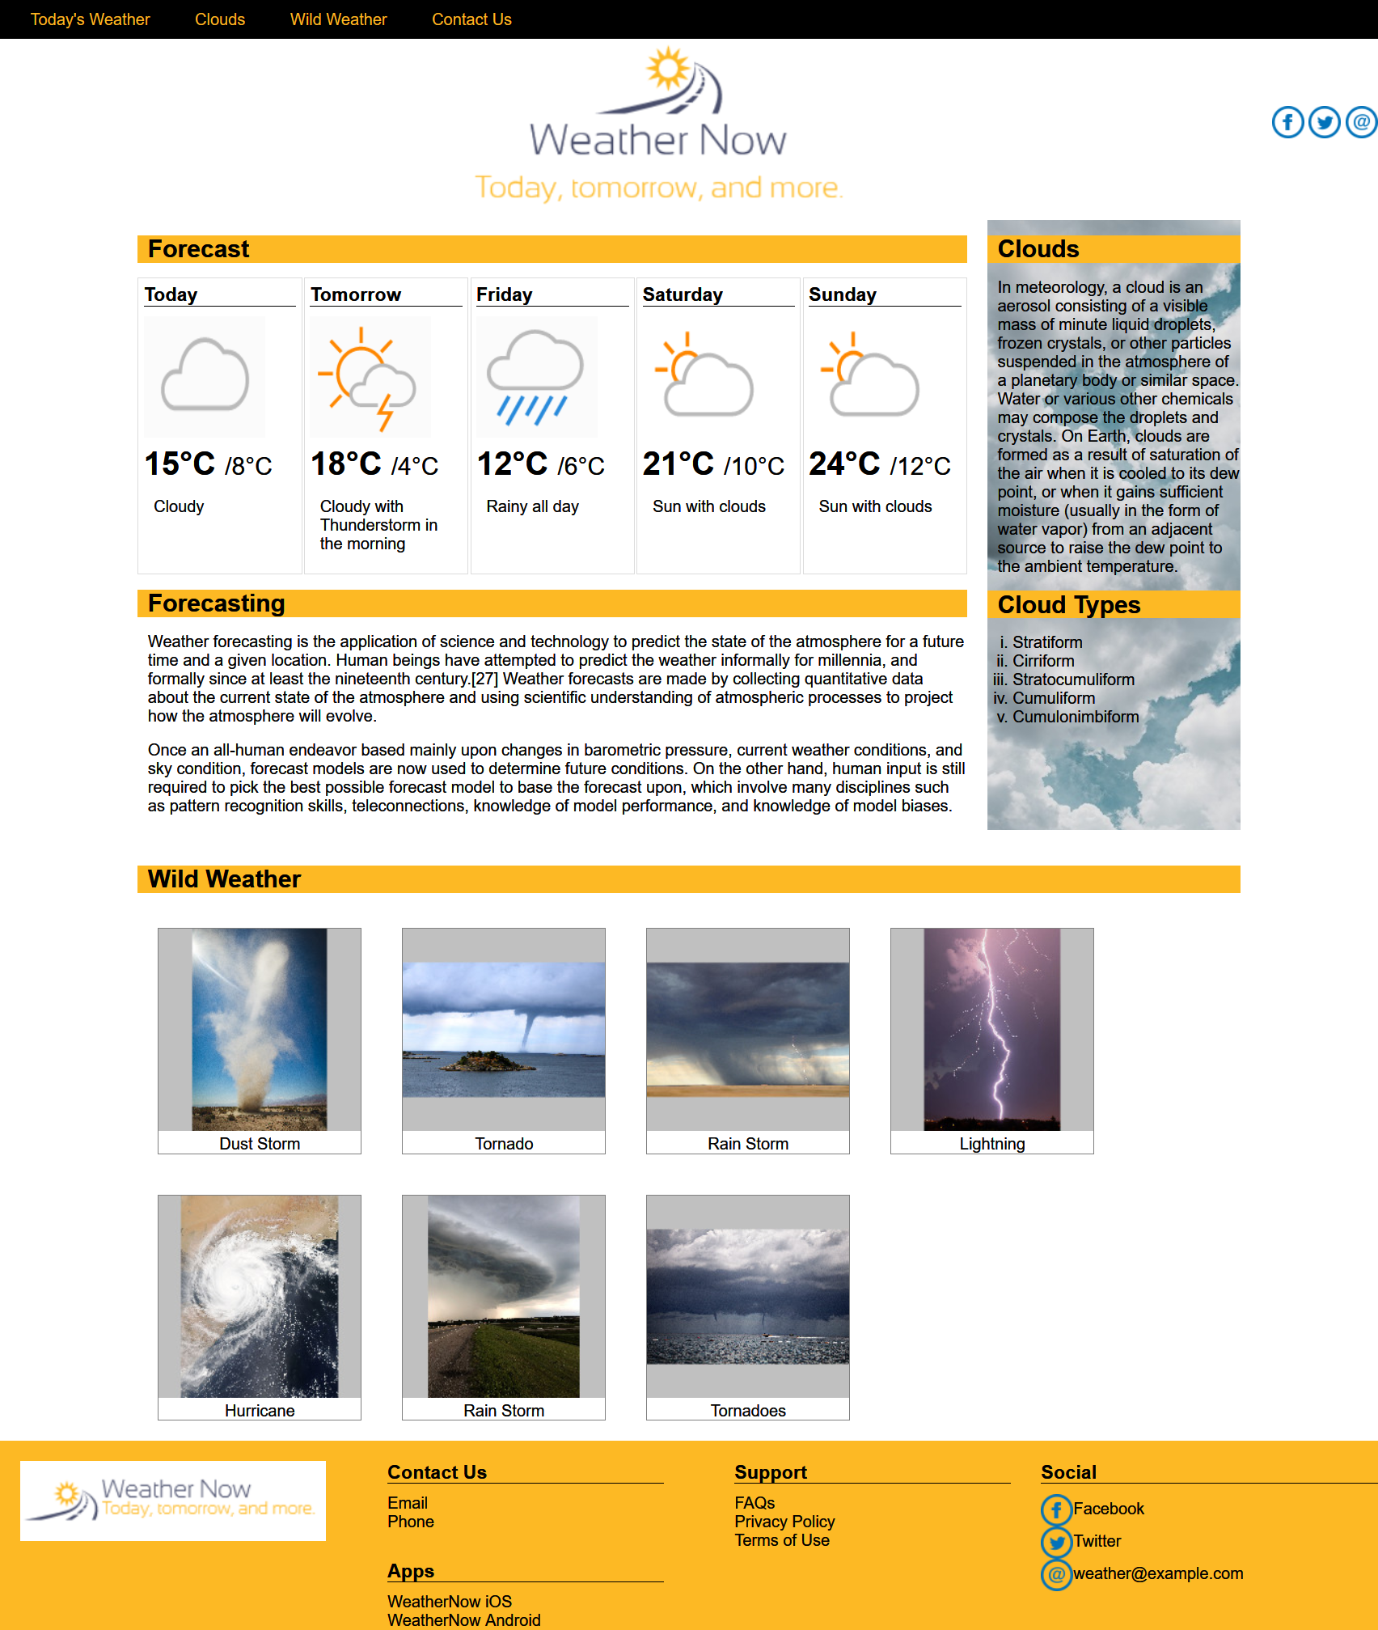

Footer

Main content

Nav

Header

